ĐỀ ÔN TẬP TIẾNG ANH VÀO 10
ĐỀ SỐ 16
Mark the letter A, B, C, or D on your answer sheet to indicate the word whose underlined part differs from the other three in pronunciation in each of the following questions.
Question 1. A. adapt B. apply C. access D. aware
Question 2. A. sculpture B. lantern C. pottery D. treat
Mark the letter A, B, C, or D on your answer sheet to indicate the word that differs from the other three in the position of primary stress in each of the following questions.
Question 3. A. answer B. admire C. advise D. adjust
Question 4. A. develop B. understand C. imagine D. consider
Mark the letter A, B, C, or D on your answer sheet to indicate the correct answer to each of the following questions.
Question 5. He _____ more confident since he joined the club.
A. is becoming B. becomes C. has become D. become
Question 6. The Great Walls of China _____ thousands of years ago.
A. is built B. was built C. is building D. was building
Question 7. I look forward _____ you on Tuesday after work.
A. see B. to seeing C. to see D. seeing
Question 8. Her mother, _____ has been working for thirty years, is retiring next month.
A. whose B. whom C. that D. who
Question 9. Peter is the _____ student in the class. He learns almost all subjects well.
A. more intelligent B. as intelligent C. most intelligent D. intelligently
Question 10. Nam is not very good _____ English.
A. in B. at C. with D. to
Question 11. He was offered the job thanks to his _____ performance during his job interview.
A. impressive B. impression C. impress D. impressively
Question 12. Jen: “Shall we eat out tonight at Diamond Restaurant?” - Erwin: “_____”
A. That’s a good idea. B. It’s very kind of you.
C. You’re welcome. D. That’s alright.
Read the following announcement and mark the letter A, B, C, or D on your answer sheet to indicate the correct option that best fits each of the numbered blanks from 13 to 16.
Writers wanted!
Wowee Magazine is looking (13) _____ writers for (14) _____ website. Pay is based on the number of people (15) _____ read your articles. You may also receive free tickets to events and free products to test.
♦ This is (16) _____ great opportunity to get valuable work experience.
♦ We want people who are: chatty, interesting, passionate, skilled
♦ Contact us at info@wowee.com
Question 13. A. for B. at C. down D. up
Question 14. A. our B. their C. my D. its
Question 15. A. who B. whom C. which D. whose
Question 16. A. ∅ B. the C. an D. a
Question 17. Put the sentences (a-c) in the correct order, then fill in the blank to make a logical text.
This is such a kid-friendly place. _____
a. The whole city is like an adventure playground.
b. At weekends, I take my daughters to the mind-blowing museum, explore a rainforest, or play outdoor games with them.
c. There are hundreds of activities to entertain children.
A. b-a-c B. b-c-a C. c-a-b D. a-c-b
Question 18. Choose the sentence that can end the text (in Question 17) most appropriately.
A. Vancouver is a perfect place for family life.
B. Vancouver is a good place for people who want to explore the nature.
C. Vancouver is a perfect destination for foreign tourists.
D. Vancouver is such a wonderful place for education.
Read the following passage and mark the letter A, B, C, or D on your answer sheet to indicate the correct word or phrase that best fits each of the numbered blanks from 19 to 24.
UNESCO has given an award to a festival (19) _____ South Korea. It decided (20) _____ South Korea's Lotus Lantern Festival to its list of intangible (21) _____ heritage. The festival is one of 25 things the UN added to its heritage list this year.
The South Korean festival (22) _____ in spring to celebrate Buddha's birthday. It symbolises lighting up the world to make things fair for everyone. The festival dates back 2,000 years. There was an ancient temple in 57 BC that royals visited to see lotus lanterns. Today, it is one of Korea's biggest festivals. People (23) _____ temples with lanterns made of paper and bamboo. Villages, towns and cities hold parades where people carry lanterns through the streets. A spokesperson said: "We will try to make the festival a cultural (24) _____ that can be loved by people around the world."
Question 19. A. on B. at C. in D. with
Question 20. A. adding B. add C. to add D. added
Question 21. A. cultural B. culture C. culturally D. cultures
Question 22. A. held B. is held C. holds D. is hold
Question 23. A. celebrate B. decorate C. honour D. hang
Question 24. A. value B. site C. wonder D. heritage
Mark the letter A, B, C or D on your answer sheet to indicate the sentence that is closest in meaning to the original sentence in each of the following questions.
Question 25. Tom said, “I want to visit my friends this weekend.”
A. Tom said he wants to visit his friends this weekend.
B. Tom said he wanted to visit his friends this weekend.
C. Tom said he wants to visit his friends that weekend.
D. Tom said he wanted to visit his friends that weekend.
Question 26. Peter usually had lunch in the canteen, but he doesn’t now.
A. Peter got used to having lunch in the canteen.
B. Peter usually has lunch in the canteen now.
C. Peter is used to have lunch in the canteen.
D. Peter used to have lunch in the canteen.
Mark the letter A, B, C, or D on your answer sheet to indicate the sentence that is made from the given cues in each of the following questions.
Question 27. She/ go back / the village/ where/born/ grow up
A. She goes back to a village where she was born and grew up.
B. She goes back to the village where she was born and grown up.
C. She is going back to village where she was born and grew up.
D. She went back to the village where she was born and grew up.
Question 28. I wish / can/ go camping/ you/ tomorrow
A. I wish I can go camping with you tomorrow.
B. I wish I can go to the camp with you tomorrow.
C. I wish I could go camping with you tomorrow.
D. I wish I could going to camp with you tomorrow.
Read the following sign or notice and mark the letter A, B, C, or D on your answer sheet to indicate the correct answer to each of the following questions.
Question 29. What does the sign say?
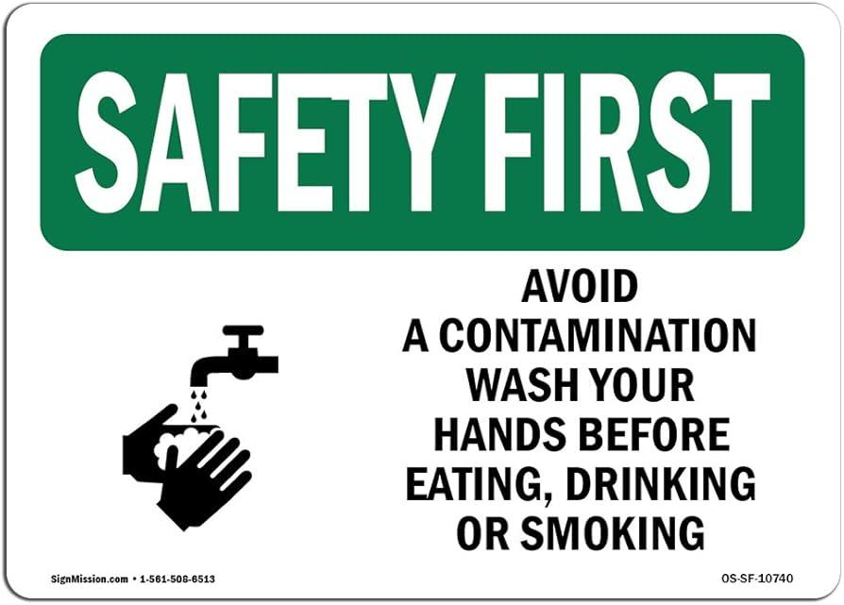
A. Wash your hands only if they look dirty before eating.
B. It is fine to eat without washing your hands first.
C. Wash your hands before you eat to keep everything clean and safe.
D. Wash your hands after eating, not before you start.
Question 30. What does the notice say?
DAN’S ICE CREAMS
Buy one, get one free!
(Special offer 12-2 p.m. only)

A. The ice cream shop is open for only 2 hours.
B. Two ice creams will cost the same as one.
C. You can get free ice creams all afternoon.
D. You can only buy 2 ice creams at a time.
Read the following passage and mark the letter A, B, C, or D on your answer sheet to indicate the correct answer to each of the following questions from 31 to 36.
Earth Hour is an annual event which asks you to switch off all your lights for one hour. The aim is to involve as many people as possible in positive change for our planet.
What is Earth Hour?
Earth Hour is organised by the World Wide Fund for Nature (WWF) and it's a big event usually at the end of March every year. On this evening, people 'go dark' - that is, switch off lights in their homes, schools and businesses all at the same time for one hour. Earth Hour started in Australia in 2007, when 2.2 million people in Sydney turned off all unnecessary lights for an hour. Since then, it has grown into an international event, and many countries around the world have taken part. Famous buildings that have gone dark for Earth Hour include the Sydney Opera House and Harbour Bridge, the Petronas Towers in Kuala Lumpur, the Houses of Parliament and Buckingham Palace in London, the Eiffel Tower in Paris, the Forbidden City in Beijing and New York's Empire State Building.
What’s the idea behind Earth Hour?
The idea is to raise awareness of environmental issues and call for action to protect nature, so that people enjoy healthy, happy and sustainable lives now and in the future.
It's true that switching off the lights for just one hour saves only a small amount of power. But this is only the beginning. On one level, participating in Earth Hour makes people think about the problem of climate change and what we can do in everyday life to protect nature.
What does ‘60+’ mean?
The logo of Earth Hour is '60+'. The number 60 is for the 60 minutes of Earth Hour, and the plus invites people to keep on taking action even after Earth Hour is finished. In fact, people who join Earth Hour say that taking part makes them want to do more for the environment. The climate activist Greta Thunberg says that 'Earth Hour is every hour of everyday.
Question 31. When is Earth Hour?
A. annual event B. at the end of March every year
C. in 2007 D. 60 minutes
Question 32. What do people do for Earth Hour?
A. Switch off non-essential lights.
B. Watch TV to participate in the campaign.
C. Raise awareness of environmental issues
D. Switch on the lights at famous buildings.
Question 33. The word “go dark” in the second paragraph is CLOSEST in meaning to _____ .
A. walking in the dark B. living in the dark
C. switch off lights D. turn on lights
Question 34. According to the passage, which of these have gone dark for Earth Hour EXCEPT _____?
A. The Petronas Towers
B. The Eiffel Tower
C. The World Wide Fund for Nature (WWF)
D. The Sydney Opera House
Question 35. According to paragraph 3, how does Earth Hour help the planet?
A. It makes people switch off lights in their homes, schools and businesses.
B. It helps people know more about climate change.
C. It encourages people to use more electricity.
D. It raises people’s awareness of environmental issues
Question 36. What is the main idea of the text?
A. Ways to save electricity
B. An introduction of Earth Hour
C. How to protect the environment
D. Some interesting stories about Earth Hour
Four phrases/ sentences have been removed from the text below. For each question, mark the letter A, B, C, or D on your answer sheet to indicate the correct option that best fits each of the numbered blanks from 37 to 40.
London, the capital city of England and the United Kingdom, is situated on the River Thames, which meanders through the city. It is renowned for its numerous bridges. Among the bridges, the oldest one is London Bridge, which was originally built of wood but reconstructed in stone in 1217. However, (37) _____, which was designed to blend in with the nearby Tower of London.
London is a thriving commercial and cultural centre with many significant financial organisations such as the Bank of England and the London Stock Exchange. They are located in the area called the City. Docklands, the former port in east London, has been redeveloped as a business centre. (38) _____. Due to the high cost of housing near the city centre, many people working in London prefer to live in the suburbs and commute to work by train or bus. London's transportation system is well-connected, with various modes of transportation available, including the red London buses, (39) _____, commonly known as 'the Tube'.
(40) _____. Although some people from other parts of Britain view it as very noisy and dirty, many others visit London only for the 'bright lights' - the theatres around Shaftesbury Avenue or the shops on Oxford Street. People also take their children to visit Buckingham Palace, where the royal family lives, and the clock tower, from which Big Ben tolls the hour. Young people, on the other hand, are lured to the pubs and comedy clubs of Covent Garden, live music concerts, and the stalls of Camden Market.
A. The West End boasts theatres, cinemas, museums, and stores
B. London is now a cosmopolitan, multicultural city which has attracted people from around the globe
C. the most unique bridge is Tower Bridge
D. black taxi cabs, and the London Underground
Question 37. __________ Question 38. __________
Question 39. __________ Question 40. __________

